What are Magnetic Circuits?
Magnetic circuits are similar to normal electrical circuits that have a closed path followed by magnetic lines of force. It is important to know that in a magnetic circuit, the magnetic lines of force originate from a point and end at the same point after completing the full path. Despite being a circuit, it is important to note that nothing flows in a magnetic circuit like current that flows in a standard electrical circuit.
As the name suggests, a magnetic circuit consists of magnetic materials which have high permeability, these materials are usually steel or iron. Magnetic circuits also include electric motors, transformers, generators galvanometers, etc.

Applications of Magnetic Circuits
Magnetic circuits remain indispensable in electrical engineering thereby having various applications in real-day life like.
- Magnetic circuits are majorly used in transformers. This is mainly because of their ability to transfer energy efficiently. These circuits result in efficient power transfer by giving direct control over power supply in circuit.
- The circuits are used in inductors for storage of energy efficiently. The magnetic circuits generate a magnetic field of electrons and the energy of these electrons is stored in inductors. Using magnetic circuits also reduces electrical noise.
- Other appliances using magnetic circuits includes electric motors and generators. They help to operate motors by converting electrical energy to mechanical energy. The generators use these circuits for performing the exact opposite task i.e. converting mechanical energy to electrical energy.

Circuit Diagram of Magnetic Circuits
The magnetic circuit diagram shown below consist of a magnetic material, generally an iron core which is used for making the solenoid part of the circuit. The solenoid with N turns creates a magnetic flux which generates a current I in the solenoid.
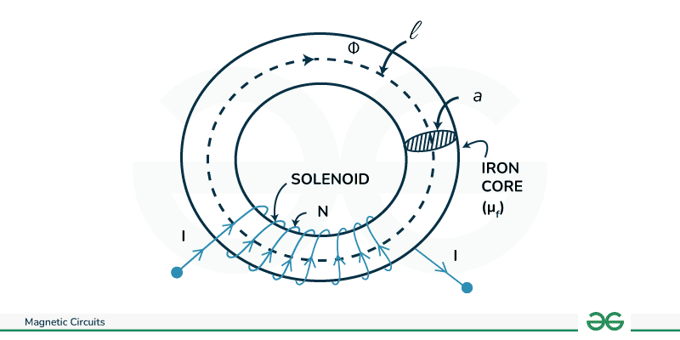Circuit Diagram

Magnetomotive force (mmf)

The magnetic pressure that sets up or tends to set up in a magnetic field is known as magnetomotive force.

A coil of N turns carrying a current I generates a magnetomotive force equal to MMF = NI

Unit: Ampere turns

Magnetic flux: The amount of magnetic lines of force set up in a magnetic circuit is called magnetic flux

Magnetic flux = MMF/S

Here S is the reluctance.

The unit of magnetic flux is weber

Reluctance: The opposition offers to the flow of magnetic flux in a magnetic circuit is known as reluctance. It is the ratio of MMF to the magnetic flux in the circuit.

Reluctance depends upon the length, cross-sectional area and permeability of the material.

$S= \frac{l}{µA}$ , l is the length and A is the area of cross section.

The unit of reluctance is AT/Weber

Magnetic field strength (H): If the magnetic circuit is uniform or the area of cross-section is uniform then the magnetomotive force per unit length is called magnetic field strength.

H = MMF/Length

Unit is AT/m

Magnetic flux density: The magnetic flux established per unit area is called magnetic flux density.

B = ϕ/A, Its unit is wb/m2 or tesla

Ohm's Law For Magnetic Circuits
Consider the magnetic circuit given below.
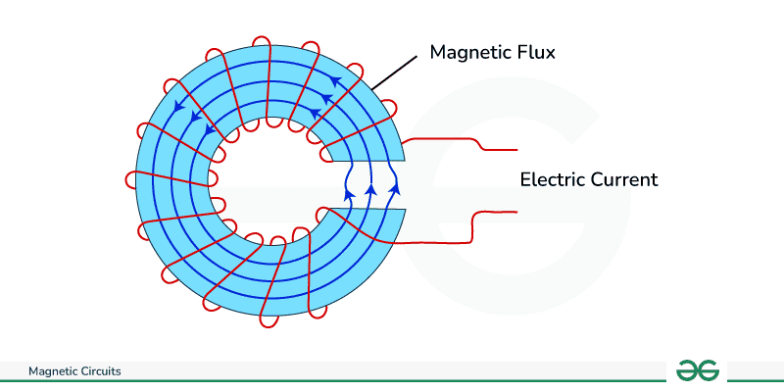Magnetic Circuit
We have already seen that magnetic circuits are analogous to electric circuits i.e. we can compare magnetic circuits to electric circuits in certain respects. That being said, we can say that there must be a law analogous to ohm's law for magnetic circuits. This indeed is true that there is a law called Rowland's law which is very similar to ohm's law. The statement of this law is:
Rowland's law states that the number of magnetic lines of force (Φ) is proportional to the magnetomotive force (F_{m}) and inversely proportional to the circuit's reluctance (S).
Let us see the analogy, According to ohm's law
V = IR
Here, V is the voltage I is the current in circuit R is circuit resistance.
Similarly for magnetic circuits
F = ΦS
Here, F is the magnetomotive force Φ is the magnetic flux S is the reluctance of the material.
The magnetomotive force can be compared to the voltage of the source while the magnetic flux can be compared to the current flow in electric circuit. The magnetic reluctance is synonymous to the resistance in electric circuit. This makes Rowland's law an equivalent version of ohm's law in magnetic circuit.

Properties of Magnetic Circuits
There are two major properties of magnetic circuits namely magnetic flux and magnetomotive force . We will discuss them here.

1. Magnetic Flux
Magnetic Flux is the term used for defining magnetic induction in magnetic circuits. It is often referred to when discussion is about strength of magnetic field in a particular region. Formally magnetic flux can be defined as a quantitative measure of magnetic field lines passing through a given region. It is generally represented by symbol Φ and can be written as
Φ = B⋅A⋅cos(θ)
Φ is the magnetic flux measured in Weber (Wb), B is the magnetic field strength measured in Tesla (T), A is the area of magnetic field lines measured in square meters (m²), θ is the angle between the magnetic field lines and the normal to the surface.

2. Magnetomotive Force (MMF)
This concept comes into picture when we talk about maintaining magnetic flux in a magnetic circuit. Similar to electromotive force in electrical circuits we talk about MMF as an analogous force. This is an important force that helps in sustaining the magnetic circuit. Formally, It is the total magnetic potential difference in a magnetic circuit and which performs the task of maintaining magnetic flux in a magnetic circuit. It can be written as
F = N⋅I
F is the magnetomotive force in ampere-turns, N is the number of turns of the coil or winding, I is the current flowing through the coil in amperes.

Difference Between Electric Circuit and Magnetic Circuit
Lets see the difference between electric and magnetic circuits.
Electric Circuits | Magnetic Circuits
It is the path for electric current to flow. | It is the path traced by magnetic flux.
It follows ohms law V=IR | It follows law analogous to ohms law F=ΦR
The force involved in maintaining circuits is electromotive force. | The force involved in maintaining circuits is magnetomotive force.
Resistance opposes the flow of current. | Reluctance is opposed by magnetic path to flux.
The flow of electrons decides current in conductor. | The magnetic lines of force decide the flux in core.

Magnetic circuits with ac excitations

